Ideation Phase
Brainstorm & Idea Prioritization Template
Date | 27 JUNE 2025
Team ID | NM2025TMID02958
Project Name | Garage Management system
Maximum Marks | 4 Marks

Prevent user deletion if assigned to an incident Template :
This guided project demonstrates how to prevent the deletion of users who are assigned to incidents within the system. It begins by creating test users and assigning incidents to them. A business rule is then created to enforce the restriction that prevents deletion if any incident is assigned to a user. This ensures important data is preserved and prevents accidental removal of users who are still linked to active work items.
The workflow also includes a test scenario to validate the behavior. First, a test is performed with an unassigned user to confirm that deletion is allowed when no assignments exist. Finally, an attempt is made to delete an unused user, verifying that the system permits this action without any errors. This process helps administrators maintain accurate user records while enforcing necessary safeguards.
Step-1: Team Gathering, Collaboration and Select the Problem Statement:
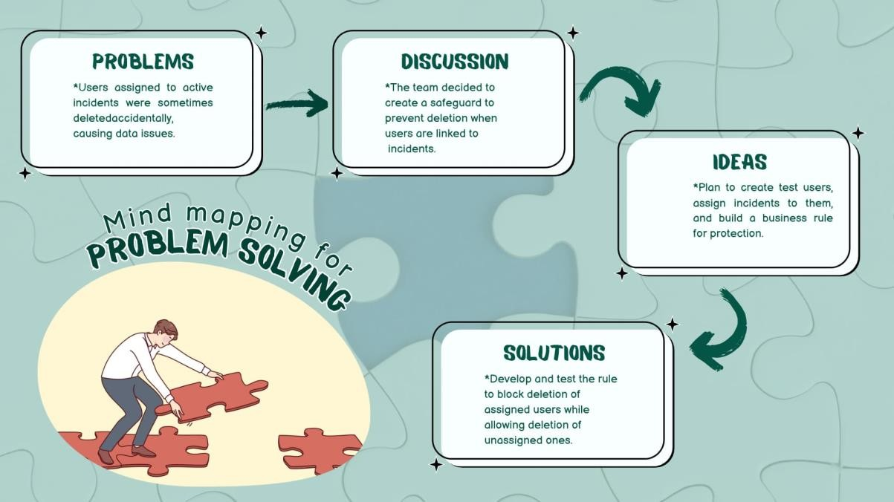
Reference: https://www.mural.co/templates/brainstorm-and-idea-prioritization

Step-2: Brainstorm, Idea Listing and Grouping:
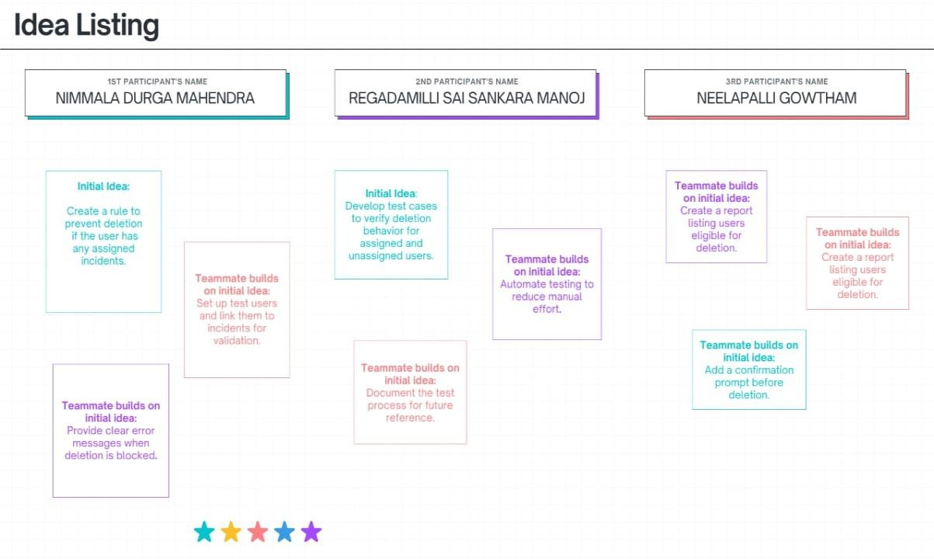
Fig2: Image that describes the work done by teammates.
Brainstorm:
Team members share ideas freely to explore solutions without judgment, encouraging creativity and participation.
Idea Listing:
All ideas from the session are written down to capture every suggestion and ensure no input is overlooked.
Grouping:
Similar ideas are organized into categories to identify patterns, highlight priorities, and simplify decision-making.
Action Planning:
Chosen ideas are turned into clear steps with assigned responsibilities and timelines.

Step-3: Idea Prioritization:

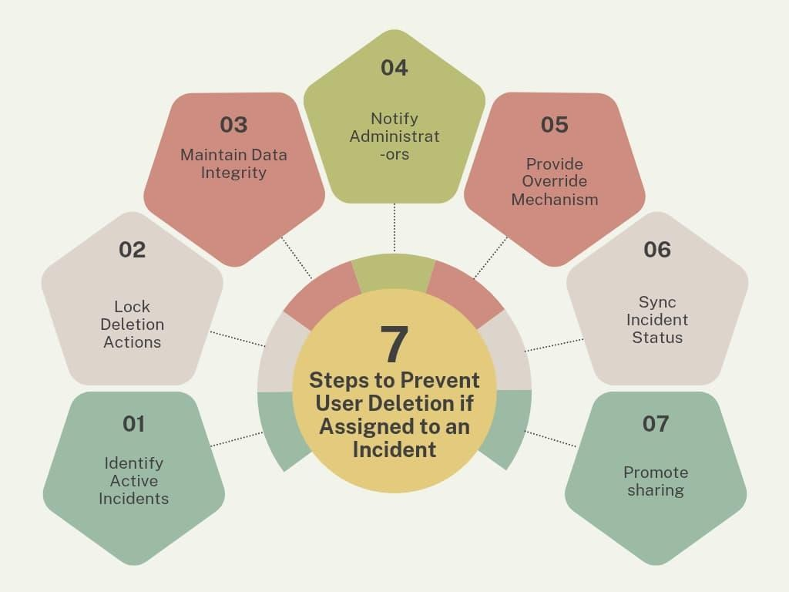
Fig3: Image of steps to prevent user deletion.
Idea Prioritization:
Idea polarization helps break down complex projects into clear, focused components. In this project, the main goal is to prevent user deletion if the account is assigned to an active incident. This approach ensures that data integrity and accountability are maintained during critical workflows. By polarizing ideas, we can separate incident management processes from routine administrative tasks. It also helps in highlighting the importance of user account security and controlled access. Each step, from detection to restriction, becomes easier to plan and implement. Clear visual representations like diagrams and flowcharts can simplify communication. Overall, idea polarization strengthens project clarity and supports smooth execution.

